Data Structures used in this code:

Tupples

Execution:

1.Have python3 working on system

2.Open two terminals

3.Change directory to the directory containing UDPServer.py, UDPClient.py and image.bmp in both terminals

4.In one terminal type 'python UDPServer.py'

The following text should appear: The server is ready to receive

5.In the second terminal type 'python UDPClient'

The image should appear in greyscale format in the same directory

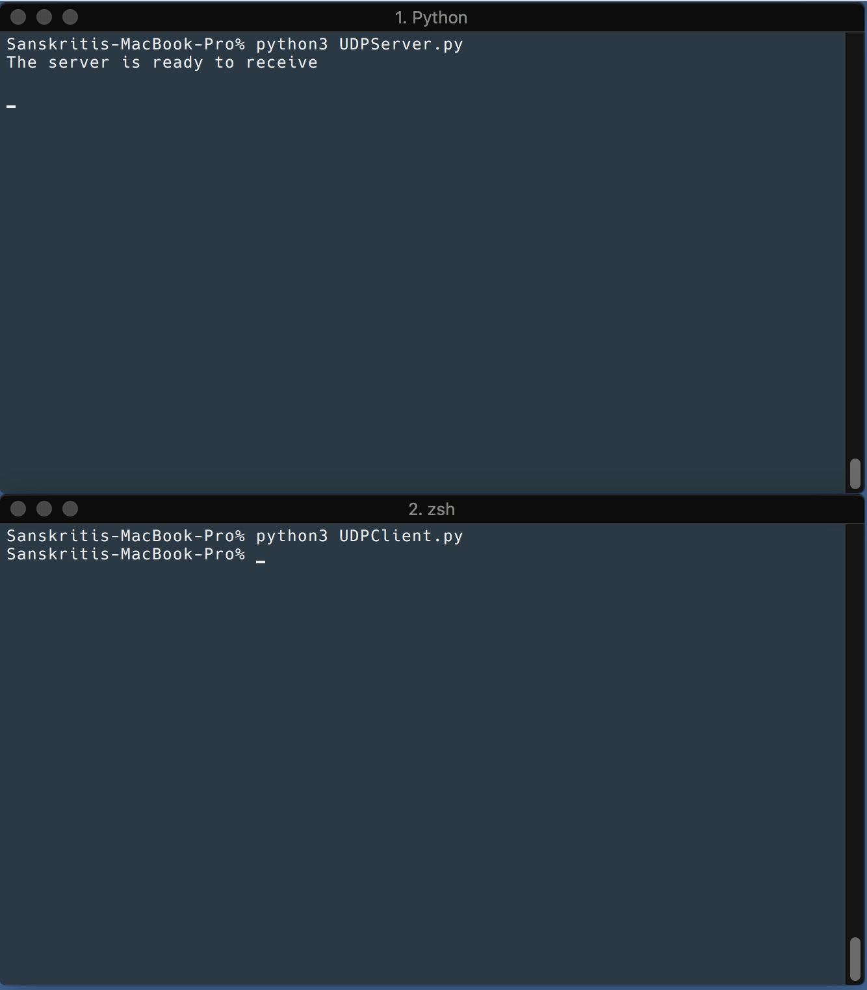

Image 1: The code being executed

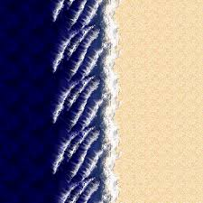

Image 2: original picture

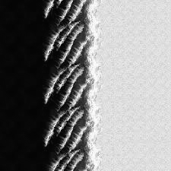

Image 3: Greyscale image